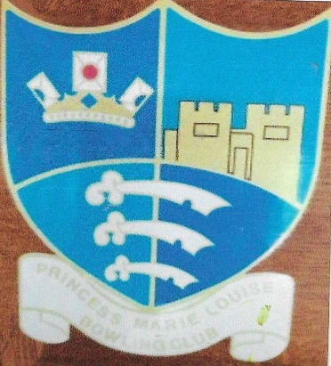
Princess Marie Louise
Bowls Club
Founded by Alderman John Ockleford Thompson 1936

History of Alderman: John Ockelford Thompson born in Springfield, Chelmsford, on 8 October 1872, he was the son of newspaper proprietor Thomas Thompson and Sarah Elizabeth Thompson (née Ockelford).

John Ockelford Thompson, CBE, DL, JP, was an influential civic figure in Chelmsford and across Essex. The son of Thomas Thompson (proprietor and editor of the Essex County Chronicle, John was educated at King Edward VI Grammar School before entering the family newspaper business as an editor and part-proprietor.

First elected to Chelmsford Council in 1907, he was elevated to Alderman that same month and served as Mayor of Chelmsford across seven distinct terms (1916—17, 1920-22, 1928-30, 1936-37, and 1939-40). He was awarded the CBE in 1938.
Thompson resided at Brierley Place, a Georgian mansion located at 160 New London Road, Chelmsford. The estate was renowned for its extensive grounds, which featured lush gardens, ferneries, and a private two-rink bowling green where Thompson bowled with friends and colleagues.

The Royal Visit of Princess Marie Louise (1936)
Princess Marie Louise was a granddaughter of Queen Victoria (the youngest daughter of Princess Helej la and Prince Christian of Schleswig-Holstein) and a devoted patron of charitable and international causes.
In 1936, during Thompson's term as Mayor, the Princess travelled to Chelmsford to officially open a conference for the League of Nations Union (LNU). Thompson, who was Chairman of the Essex Federal Council of the League of Nations Union, hosted the royal gathering at his private residence, Brierley Place.
While touring the grounds, Princess Marie Louise was impressed by Thompson's estate and paid special compliments to his manicured gardens and lawn bowling green.

The Founding of P.M.L. Bowls Club
Taking advantage of her enthusiasm and praise for his green, Thompson asked the Princess if she would graciously grant royal permission to name a bowling club in her honour.
Princess Marie Louise agreed, leading directly to the establishment of the Princess Marie Louise Bowling Club (now commonly known as P.M.L. Bowls Club) in 1936. Initially, members played directly on the two-rink green situated within the grounds of Brierley Place.
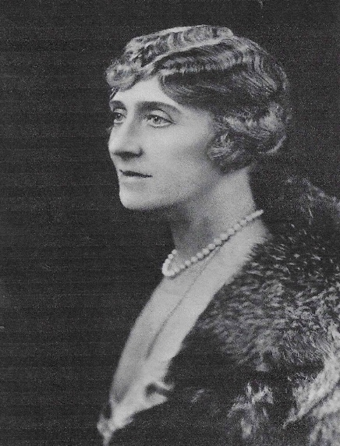
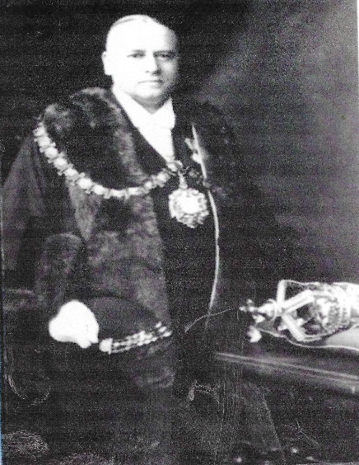

John Ockleford Thompson
Princess Marie Louise

Wartime Tragedy and the Club's Survival
The history of Brierley Place met a tragic turn during the Second World War. On 13 October 1940, during-Thompson's final term as Mayor, a lone Luftwaffe bomber struck Chelmsford. A high-explosive bomb hit Brierley Place directly, destroying much of the house and killing 68year-old John Thompson alongside his wife Emma, their son, two young granddaughters, and a household servant.
Large crowds lined the streets of Chelmsford for the civic funeral procession to the Borough Cemetery, where he was laid to rest. He is commemorated locally on the King Edward VI Grammar School war memorial and at Chelmsford's civic memorials.
Following the tragedy, Thompson's surviving family offered the club a parcel of orchard land bordering Bradford Street (once part of the original estate established by John George Bond, founder of Chelmsford's major department store). The club members purchased the land to secure a permanent home.
By 1945, the club opened with a three-rink green and became one of the founding members of the Chelmsford and District Bowling Association.

Post-War Expansion to Present Day
As membership grew, the club expanded from three rinks to four in 1949, five in 1956, and finally to a full six-rink outdoor grass green in 2002.
The original wooden pavilion was modernized over several decades, culminating in a brick clubhouse featuring dedicated changing facilities, a fully licensed bar, and space for indoor short-mat bowls.
Today, the club operates year-round from Bradford Street in Chelmsford—competing outdoors during the summer in local Essex leagues and hosting indoor short-mat matches throughout the winter months.

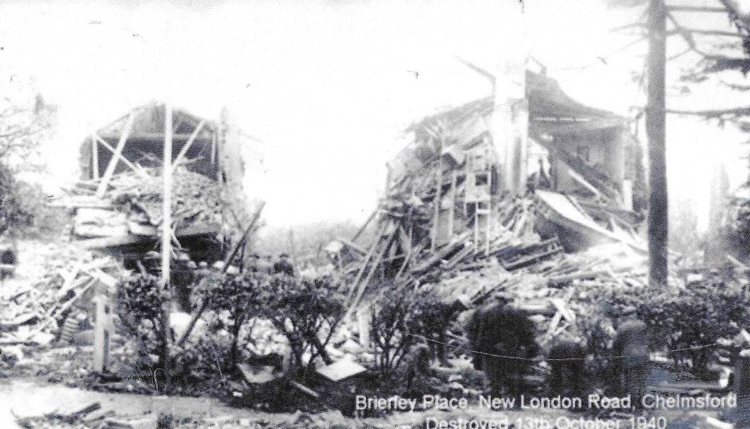

Brierley Place following a direct hit by a German Bomb, October 13th, 1940

Princess Marie Louise Bowls
Founded by Alderman John Ockleford Thompson 1936
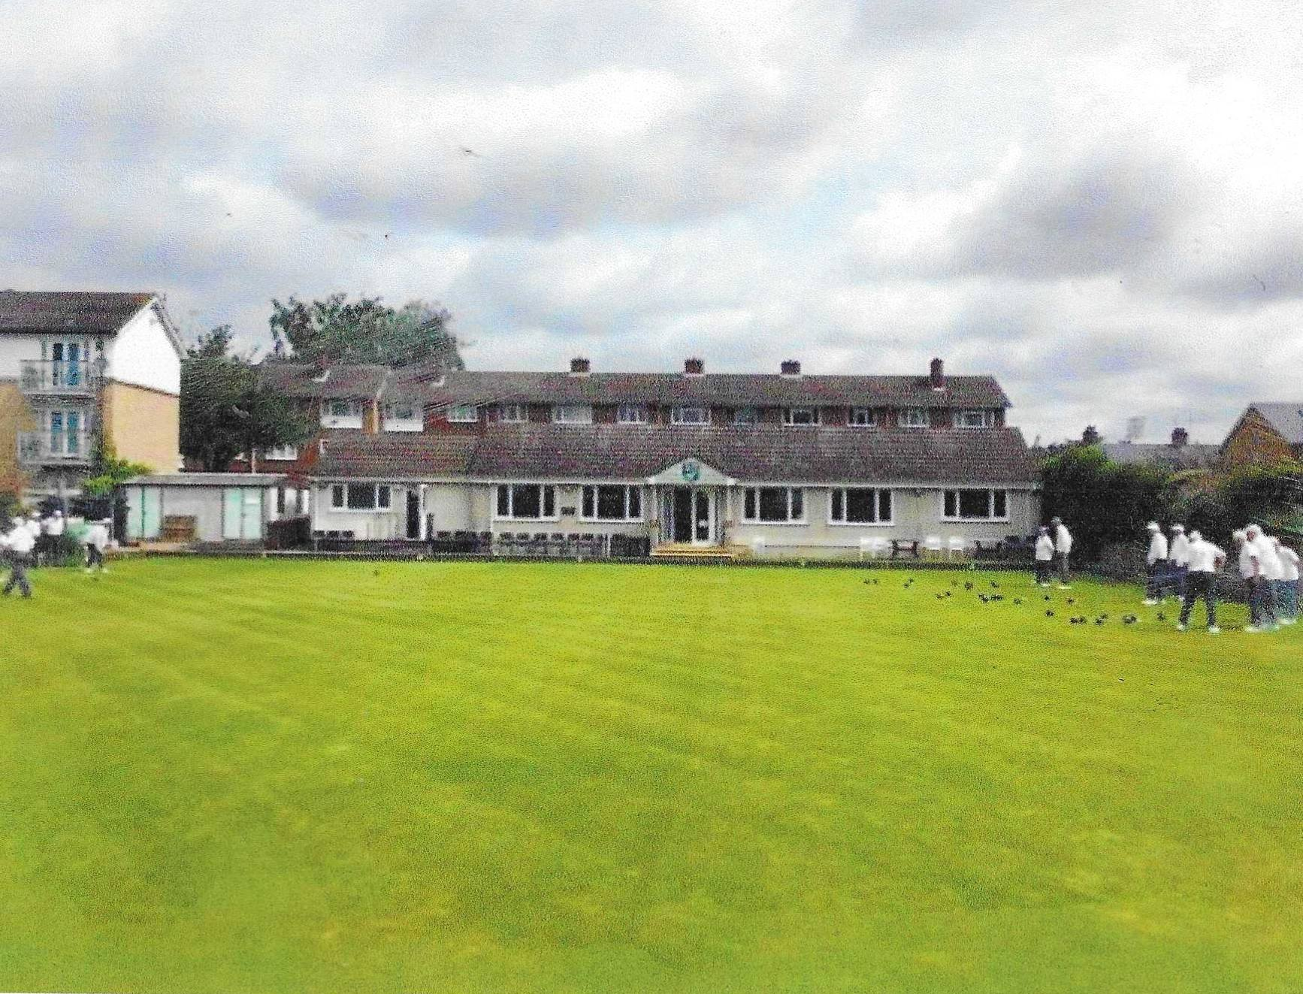

Princess Marie Louise Bowls club as it looks today

